**Successfully Node Js connected with MongoDB**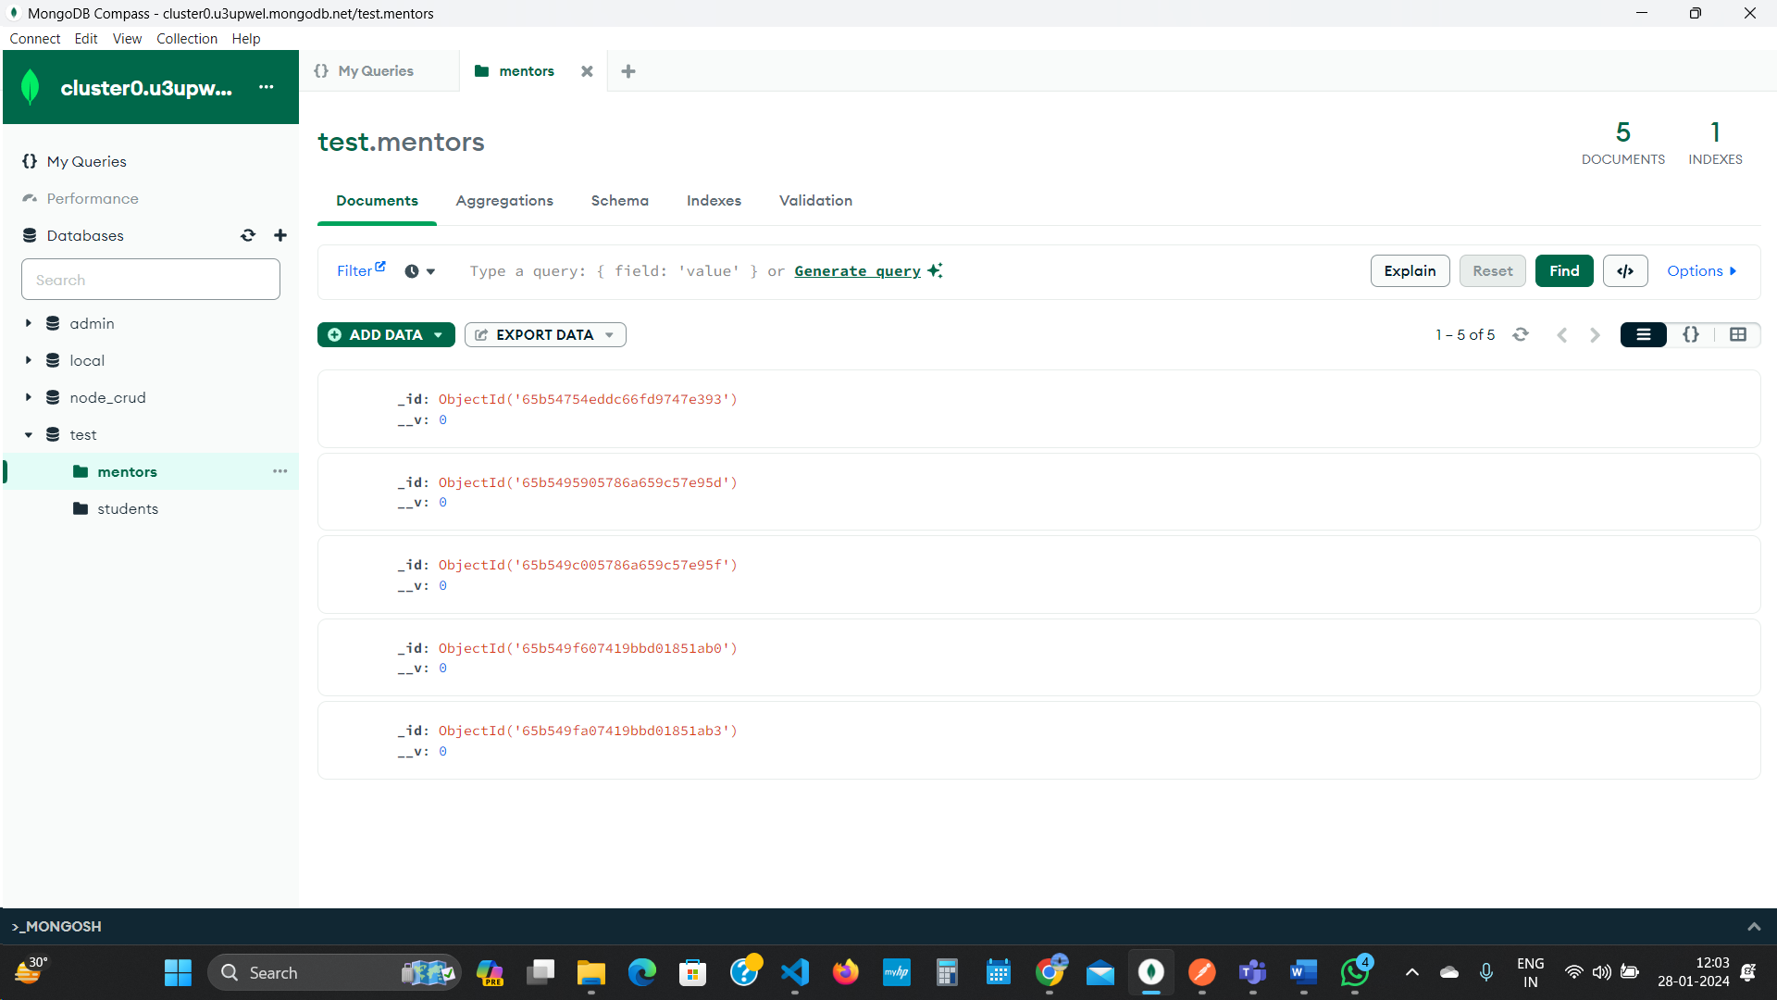  
  
 1)Write API to create Mentor  
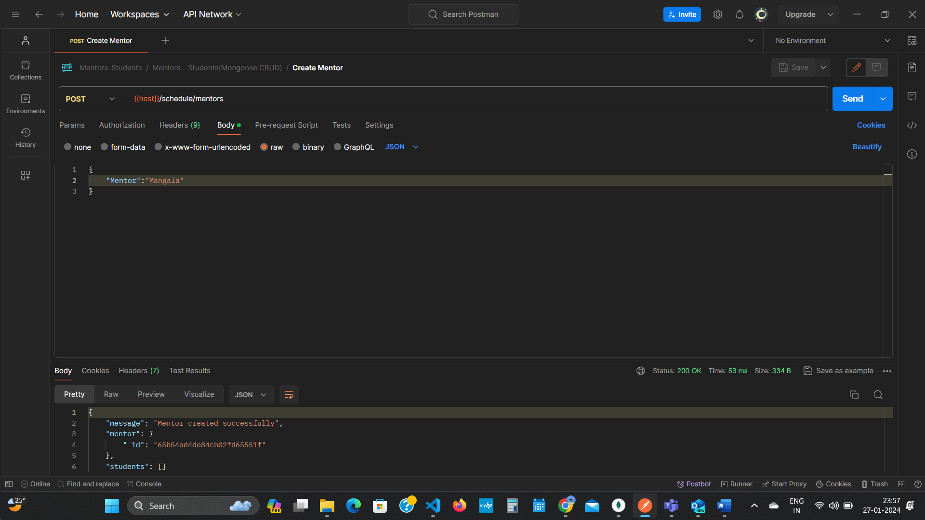  
  
2) Write API to create Student  
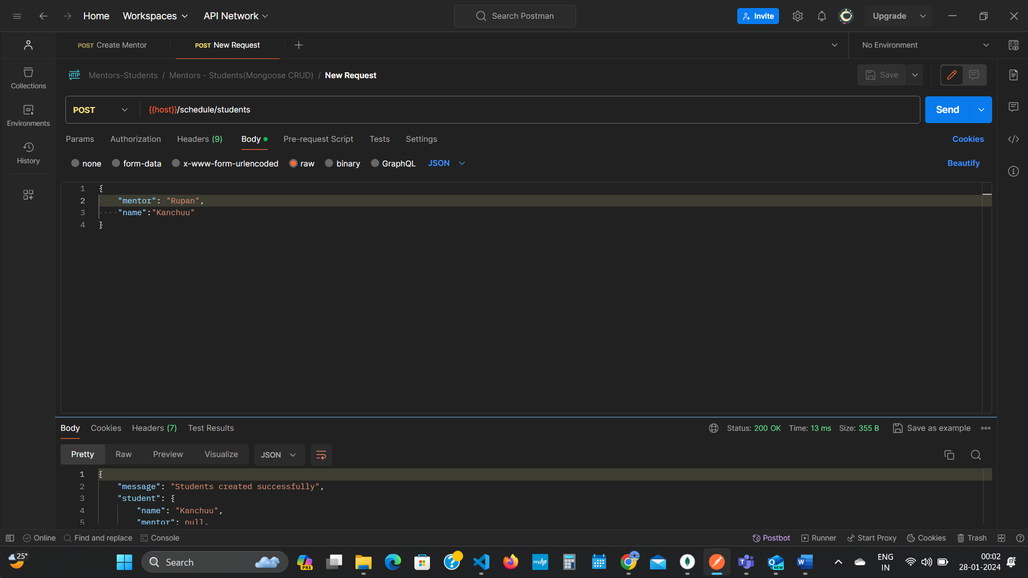  
  
  
3) Write API to Assign a student to Mentor

* Select one mentor and Add multiple Student
* A student who has a mentor should not be shown in List

1. 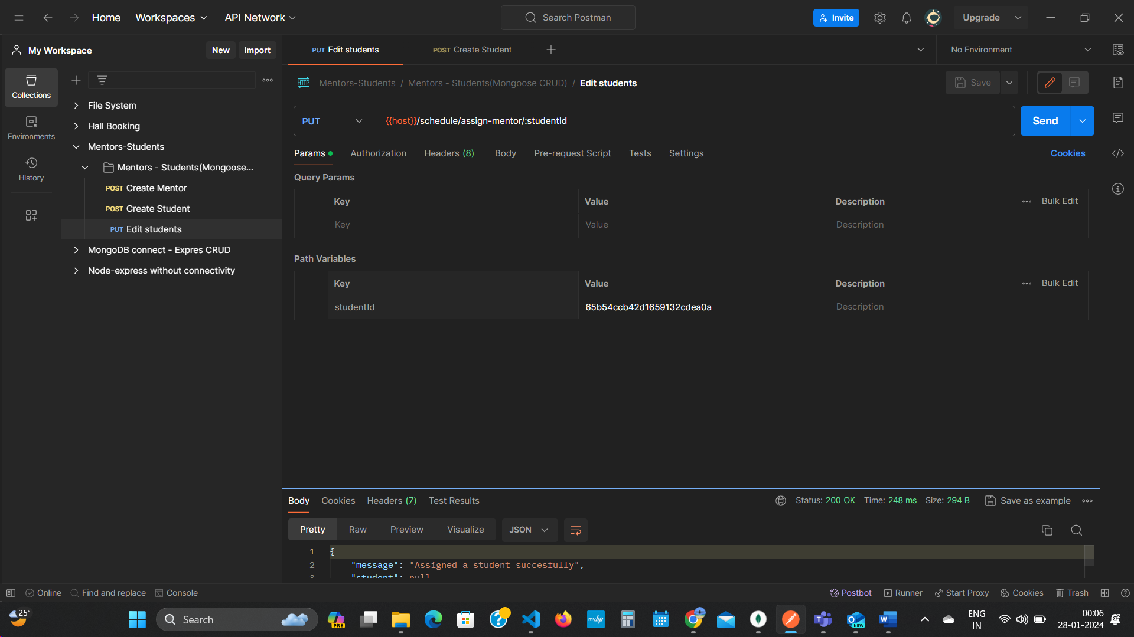  
     
   4)Write API to Assign or Change Mentor for particular Student

* Select One Student and Assign one Mentor  
  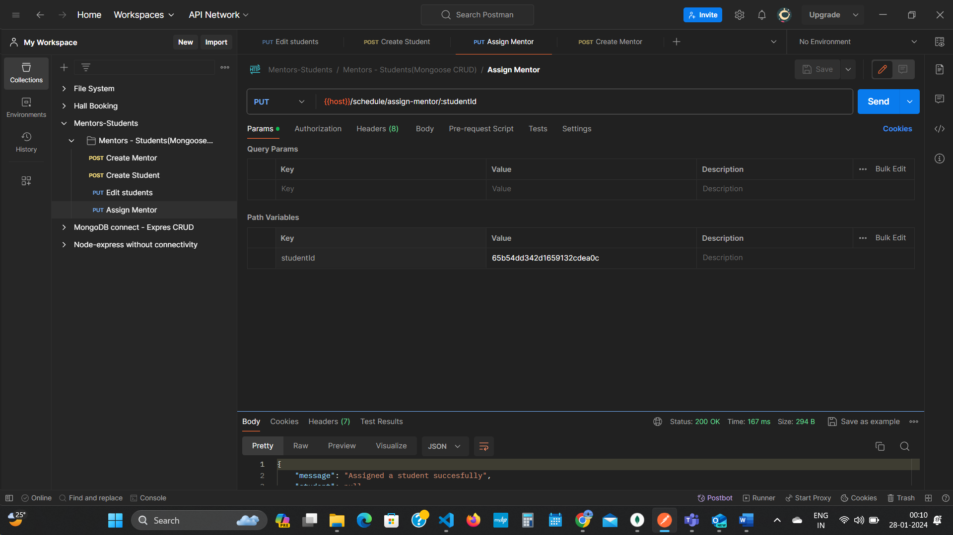  
    
  5)Write API to show all students for a particular mentor  
  